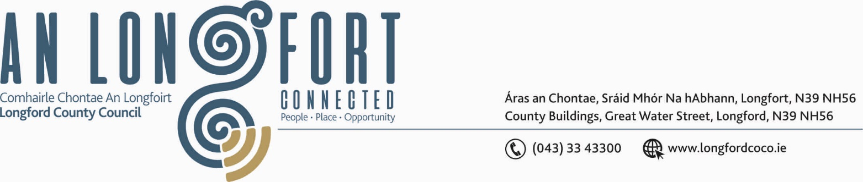

GRANARD MUNICIPAL DISTRICT

Corporate Affairs,
Aras an Chontae,
LONGFOIRT.

6th May 2020.

To: Each Member of Granard Municipal District.

Dear Member,

You are requested to attend Meeting of Granard Municipal District to be held in
the Sports Hall, Leisure Centre, Albert Reynolds Peace Park, Longford
on Tuesday, 12th May 2020 at 2.00 p.m. to transact business, as set out on the Agenda hereunder.

Yours sincerely,


_______________
Anne Lee,
Meetings Administrator.

AGENDA

Prayer before meeting.

1. Confirmation of Minutes of Granard Municipal District Meetings held on the
6th April 2020 - copies enclosed

2. Matters arising from Minutes.

3. Declaration of Interest by Members.

4. Area Engineer’s Progress Report.

5. Update on Granard Public Art Features.

6. Consideration of Nominee for the 2020 Cathaoirleach Awards.

7. Fix date for 2020 Granard Municipal District Annual Meeting.

8. Correspondence received from the Secretary, Ballinamuck Enterprise/Twinning Committee regarding request for reception in July for Ballinamuck/Essert Twinning –enclosed.

9. (a) Consideration of the Taking in Charge of Beechwood Park, Granard
– report enclosed.
(b) Consideration of the Taking in Charge of Sraid an Mhuilinn, Drumlish
– report enclosed.

10. Notices of Motions, submitted by Councillors, as listed hereunder –

Senator M. Carrigy – received prior to his election to Seanad Éireann on the 3rd April 2020.

“I call on Longford County Council to secure funding to provide a footpath from Lisryan Village to Lios na Gaoithe Estate.”

“I call on Longford County Council to apply for a Low Cost Safety Scheme at Killeen, Granard to improve sightlines junction.”

“I propose that Granard MD allocate funding from the 2020 budget to carry out improvements at St Johns Graveyard in Ballinalee.”

Councillor P.J. Reilly.

“That Public Lights be installed on the Barrack Road leading to the unused shopping centre and the four industrial units as this area is used by the general public accessing the units and for parking cars. Currently there is no public lighting in this area.”

“This Municipal Area and the Council to assist, support and help to the Board of Management on Cnoc Mhuire to provide a Bus Park so as to take the student buses off the N55. A bus park would leave it more secure for both students and the main traffic at school times.”

Councillor Turlough McGovern.

“That Road safety measures be undertaken in the Teemore Industrial Estate
i.e. rumble strips, ‘slow’ signs, speed ramps, as concerned business owners have highlighted ongoing issues of speeding in their estate.”

"That Longford County Council suspends commercial rates for the rest of the year due to the COVID- 19, to prevent pressure on businesses, if and when they re-open.”

Councillor Paraic Brady.

“I call on Longford County Council, in the interest of public safety, to put in a footpath from Ennybegs Village to Aughaboy Graveyard.”

“I am calling on Longford County Council to invest in a more mobile CCTV system as there is a major increase in fly tipping and house waste being dumped in north Longford.”

Councillor Garry Murtagh.

“I am asking for the support of the Members in seeking an amendment to the County Development Plan for 2021 - 2027 and, if possible, to planning applications for the remainder of the current Development Plan.

With regards to private/affordable/social housing estates/development,
I propose that all dividing and boundary walls be of masonry construction and suitably finished/rendered as standard, as timber-fencing or hedging, acting as divisions between properties or estate boundaries, are not of adequate standard and are no longer acceptable in County Longford.

Reasons for Motion:

• Longevity of boundaries between properties and estates.
• Reasonably maintenance free.
• Aesthetically pleasing.
• Issues of contention between homeowners/tenants/landowners.

11. A.O.B.



